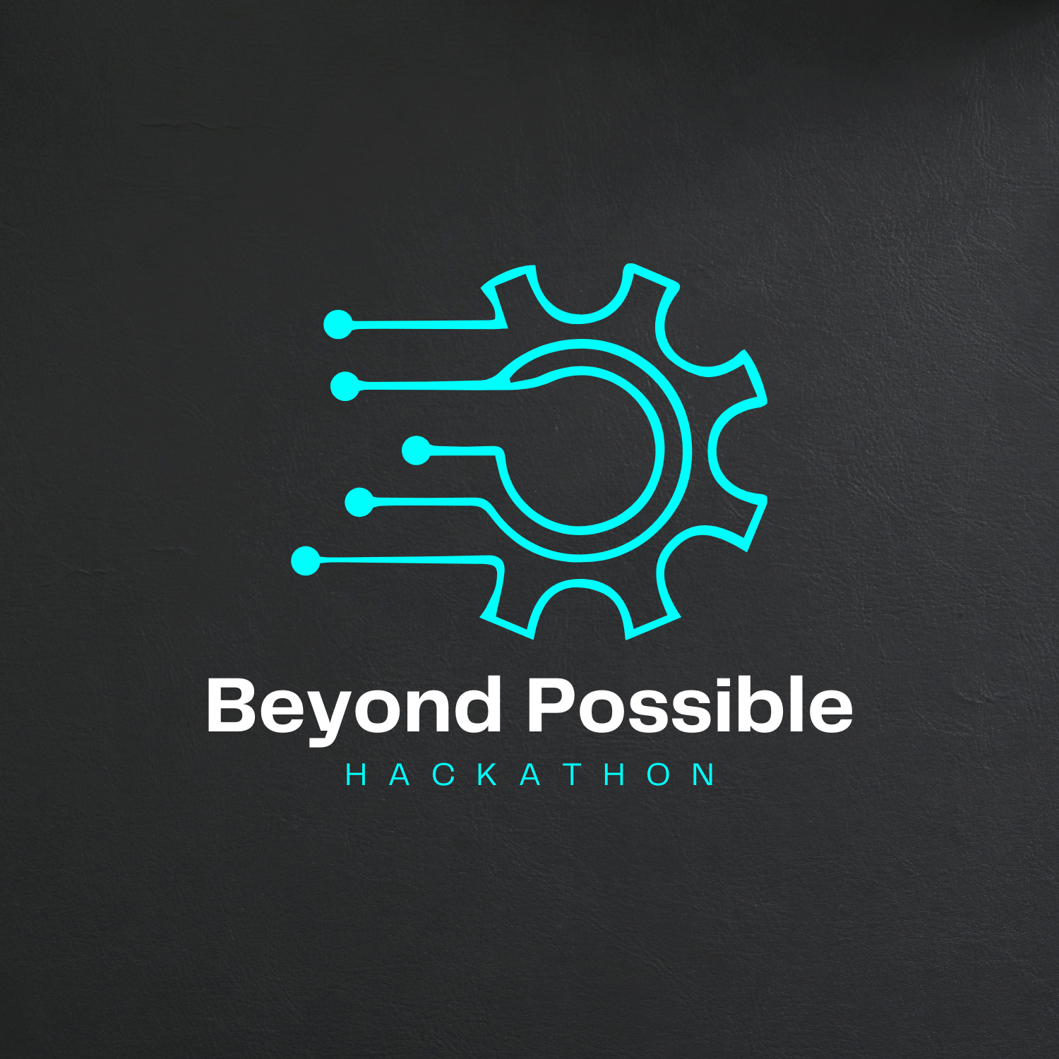

**General Attendance:**

Cipher Craft has seen growing attendance since its beginning in 2022, and we hope to continue this at our third hackathon. In our recent hackathon we have around 200 participants. Cipher Craft will be the **biggest hackathon** of all the time in **Lahore**.

**Talent Pool:**

Of the hackers at our past hackathon, over 75% were majoring in computer science and information technology. Furthermore, 25% of all hackers were upperclassmen, the targets for both internships and entry-level jobs.

**Outreach:**

As Cipher Craft has grown in popularity, our student body has expanded from being strongly centered in Lahore to being well distributed across universities all over the Lahore and even into Pakistan. In our 2023 event, more than 60% of our hackers were from other schools, including Comsats University, Fast Islamabad, Punjab University, and even high schools in Lahore.

What is Cipher Craft?

CipherCraft is more than just a hackathon; it's a dynamic platform designed to ignite minds through the transformative power of code. With a deliberate focus on collaboration in the field of Computer Science, entrepreneurship, and women empowerment, CipherCraft is committed to fostering new connections and reshaping perceptions in the coding community. Muhammad Nouman envisions CipherCraft as a catalyst for inspirational and intellectual acceleration within the coding realm.

Why Sponsor?

promotion/brand awareness

Sponsoring Cipher Craft comes with a whole host of benefits that we have outlined below. Besides these one of the most important is your own self-promotion. Coming out to Cipher Craft, giving a challenge, mentoring students, all of this helps to create a perception of your company and brand in the mind of students. It is an easy and effective way to promote your products and your company.

recruitment

By sponsoring Cipher Craft, not only do you get your name out there, but you also are in contact with possible future employees. Cipher Craft attracts some of the brightest minds across that could be put to work for your company. Cipher Craft is a perfect environment to meet, chat, and even interview potential candidates for jobs and internships.

new technology

Is there a new technology your company has just released? An API that you want to gain traction? Well look no further. Hackathons are a prime location to test new, cutting-edge technologies and their applications. Incentivize students to pursue technologies that you think could drive future industries by creating a challenge and see what their imaginations can bring forth.

inspiration

Inventive minds and fresh eyes can help bring a new mindset to a challenge or problem. Let Cipher Craft participants take a crack at challenging problems in your field of operations or maybe even the world at large you want to see fixed. Not only can you provide inspiration to our participants but we are sure they will provide some to you as well.

Sponsorship Perks

` Bronze Silver Gold Platinum

50000 100,000 175,000 250,000

|  |  |  |  |  |
| --- | --- | --- | --- | --- |
| Distribute API. |  |  |  |  |
| Distribute Swag |  |  |  |  |
| Resume Access |  |  |  |  |
| Bring Mentors |  |  |  |  |
| Bring Judges |  |  |  |  |
| Logo on Shirt |  |  |  |  |
| Logo on Site |  |  |  |  |
| Logo On Flex |  |  |  |  |
| Dedicated Standee |  |  |  |  |

None of these packages fit your business?

Email us at: [2022cs49@student.uet.edu.pk](mailto:2022cs49@student.uet.edu.pk)

**Sponsorship Perks Details**

**API:** Provide an API or a test data set that your company uses and see what our hackers can make with.

**SWAG:** Students love free stuff. Bring swag such as shirts, socks, stickers, or anything else with your logo on it to get students to engage with company.

**MENTORS:** Help guide teams on their road to success with technical mentorship and create a personal relationship with students.

**JUDGES:** Teams love to talk about their hack. Bring people from your company who are interested in listening to these students and help us pick the best projects amongst the group to go to the finals! If you have a sponsor challenge, your judges will be responsible for picking the team that wins the sponsored prize.

**RESUME ACCESS:** Help your talent search by getting access to our database of resumes that we collect from participants when they register for the hackathon.

**DEDICATED STANDEE:** Help your company by displaying a dedicated standee throughout the event that would help your company to grow.



Cipher Craft

[2022cs49@student.uet.edu.pk](mailto:2022cs49@student.uet.edu.pk)

<https://ciphercrafthackathon.netlify.app/>

For more Information kindly contact us through our email: [2022cs49@student.uet.edu.pk](mailto:2022cs49@student.uet.edu.pk)

Or contact number: +92 322 8429291